**1. MODULES**

**1.1 ADMIN MODULE**

* Authentication

1. Username and Password will be given.

2. Login Failed will be displayed if Username and Password

are wrong.

3. After login admin can view user and worker information.

* Add

1. Users data can be added if details are known.

2. Workers data can be added if details are known.

* Delete

1. Admin can delete the user data if there is a problem.

2. Admin can delete the worker data if there is an issue.

* View data

1. Admin can view the user and worker information.

* Update

1. Admin can update user and worker data if there any changes with it.

**1.2 USER MODULE**

* Authentication

1. Username and Password will be given.

2. Login Failed will be displayed if Username and Password

are wrong .

3. Verifies the details with database and logs in if TRUE.

* **REGISTRATION**

1. All required fields are given.

2. Successfully registered.

3. Update database with provided details.

* **PREFERENCE**

1. The user can choose nearby worker of their own choice.

2. The user can contact worker if there is a need.

**1.3 WORKER MODULE**

* Authentication

1. Username and Password will be given.

2. Login Failed will be displayed if Username and Password

are wrong .

3. Verifies the details with database and logs in if TRUE.

* Registration

1. All required fields are given.

2. Successfully registered.

3. Update database with provided details

* Status

1. The worker should update the status.

2. For example worker is on working, status should be working.

3. The status will get updated in the database.

**2. SOFTWARE REQUIREMENT SPECIFICATIONS**

**2.1 PURPOSE:**

The project is to make the availability of workers in their respective areas. The user can choose nearby worker of their own choice and get the work done quickly.

**2.2 SCOPE:**

The scope of this project is to know the workers who are nearby and the type of workers also. By this website we can solve the household problems in easy and quick way.

**2.3 OBJECTIVE:**

The existing system involves only tells us that type of workers and nearby workers. To make it more effective we are including the status of the worker. It means if the worker is not available then status of the worker gets updated in the database.

**2.4 EXISTING SYSTEM:**

The existing system includes only information about the nearby workers and their type.

Drawbacks:

1 .It is applicable to people who are using android mobiles.

2. Some uneducated people feels difficult to use it.

**2.5 PROPESED SYSTEM:**

The proposed system includes workers contact such that the user can call worker of their own choice and get the work done.

Advantages:

1. Easy and better services.

2. Un-Employment will be reduced.

3. Time saving for the workers and use

4. Nearby workers are assigned to the people for their respective services

**2.6 REQUIREMENT ANALYSIS**:

**Analysis focuses on producing a model of the system called the analysis model, which is correct, complete, consistent and verifiable. Analysis model is composed mainly of three individual models.**

* **Functional model**
* **Analysis object mode**
* **Analysis dynamic model**

**The functional model is represents with use of case diagrams, the object model with class diagram and the dynamic model with state chart and sequence diagrams.**

**2.7 FUNCTIONAL REQUIREMENTS**

The LOCAL WORKERS is utilized to manage and control the activity of a local service. The user can contact the worker directly through mobile number. The availability of the worker can also viewed by the user. Only the admin can change the details.

**2.8 NON-FUNCTIONAL REQUIREMENTS**

Non-functional requirements are the limitations under which system should provide its services to users. Following are the non-functional requirements for the project.

**2.8.1 RELIABILITY:**

The system is more reliable because of the qualities that are inherited from the chosen platform java. The code built by using java is more reliable.

**2.8.2 COST:**

The cost of development and maintenance is minimum. As this project uses all open source tools to develop, the cost of construction is low.

**2.8.3 PERFORMANCE:**

The system is developed using high-level languages and using advanced languages for front end and back end. It will give response to user within less time.

**2.8.4 SUPPORTABILITY:**

The system is designed to the cross platform supportable. The system is supported on the wide range of hardware and any software platform, which is having JVM, built into the system.

**2.8.5 SECURITY:**

This avoids the non-authorised users and workers access to the system.

**2.9 PSEUDO REQUIREMENTS:**

**2.9.1 SOFTWARE REQUIREMENTS**

1. Web server - Xampp server

2. Operating System - Supports WINDOWS/LINUX

3. NET BEANS - Supports WINDOWS/LINUX

**2.9.2 HARDWARE REQUIREMENTS**

1. Processor - Intel core i3 or i5

2. RAM - 3GB OR ABOVE

3. Hard Disk - 256GB OR ABOVE

**3. DATABASE CONNECTIVITY**

**3.1 ADMIN LOGIN**

|  |  |
| --- | --- |
| **FIELD** | **TYPE** |
| Username | Varchar2(20) |
| Password | Varchar2(20) |

**3.2 USERS LOGIN**

|  |  |
| --- | --- |
| **FIELD** | **TYPE** |
| Username | Varchar2(20) |
| Password | Varchar2(20) |

**3.3 WORKERS LOGIN**

|  |  |
| --- | --- |
| **FIELD** | **TYPE** |
| Username | Varchar2(20) |
| Password | Varchar2(20) |

**3.4 USERS REGISTRATION**

|  |  |
| --- | --- |
| **FIELD** | **TYPE** |
| Name | Varchar2(20) |
| PhoneNumber | Varchar2(20) |
| Username | Varchar2(20) |
| Password | Varchar2(20) |

**3.5 WORKERS REGISTRATION**

|  |  |
| --- | --- |
| **FIELD** | **TYPE** |
| First Name | Varchar2(20) |
| Last Name | Varchar2(20) |
| Phone Number | Varchar2(20) |
| Experience | Varchar2(20) |
| Status | Varchar2(20) |
| Type of worker | Varchar2(20) |
| Pincode | Varchar2(20) |
| Username | Varchar2(20) |
| Password | Varchar2(20) |

**3.6 ADMIN LOGIN**

|  |  |
| --- | --- |
| **Username** | **Password** |
| madhu | 3131 |

**3.7 USERS LOGIN**

|  |  |
| --- | --- |
| **Username** | **Password** |
| ross95 | 2345 |
| james84 | 452322 |
| smith60 | abc12 |
| david56 | 99999999 |
| mike28 | 4567 |

**3.8 WORKERS LOGIN**

|  |  |
| --- | --- |
| **Username** | **Password** |
| madhu | madhu12 |
| sai | sai452322 |
| raghu60 | abcde12 |
| ram56 | 77888 |
| raj28 | 00000 |

**3.9 USER REGISTRATION**

|  |  |  |  |
| --- | --- | --- | --- |
| **Name** | **Phone Number** | **Username** | **Password** |
| Paul | 9182998464 | ross95 | 2345 |
| James | 8978243637 | james84 | 452322 |
| Smith | 9865321245 | smith60 | abc12 |
| David | 8885136169 | david56 | 99999999 |
| Mike | 9010953207 | mike28 | 4567 |

**3.10 WORKER REGISTRATION**

|  |  |  |  |  |  |  |  |  |
| --- | --- | --- | --- | --- | --- | --- | --- | --- |
| **First**  **Name** | **Last**  **Name** | **Phone Number** | **Experience** | **Status** | **Type of**  **worker** | **Pincode** | **Username** | **Password** |
| Star sai pavan | Machireddy | 8328540402 | 3 | Available | compter | 522660 | Merrupu teega | john |
| Krishna | Mallampati | 9182998463 | 5 | Available | Electrician | 522660 | krish | 4567 |

**4. OUTPUT SCREENS**

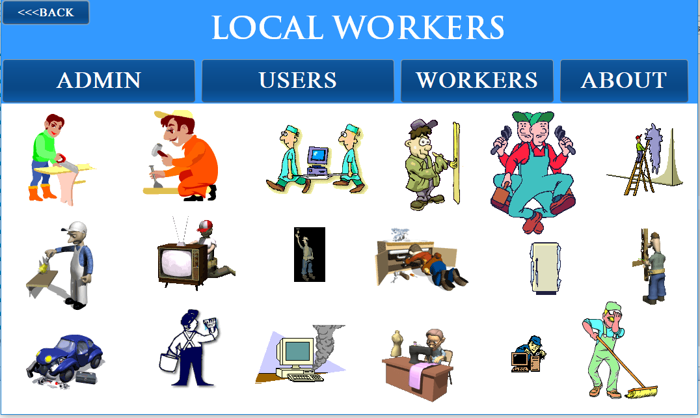

**Fig.5.1 Homepage**

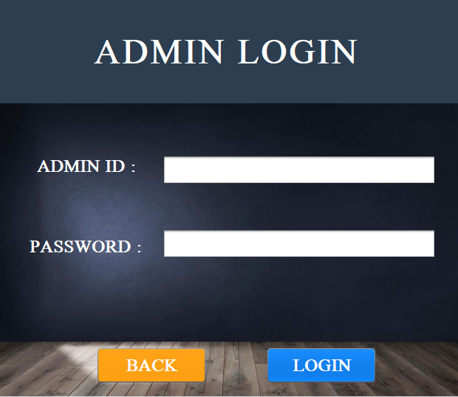

**Fig.5.2 Admin login pag**

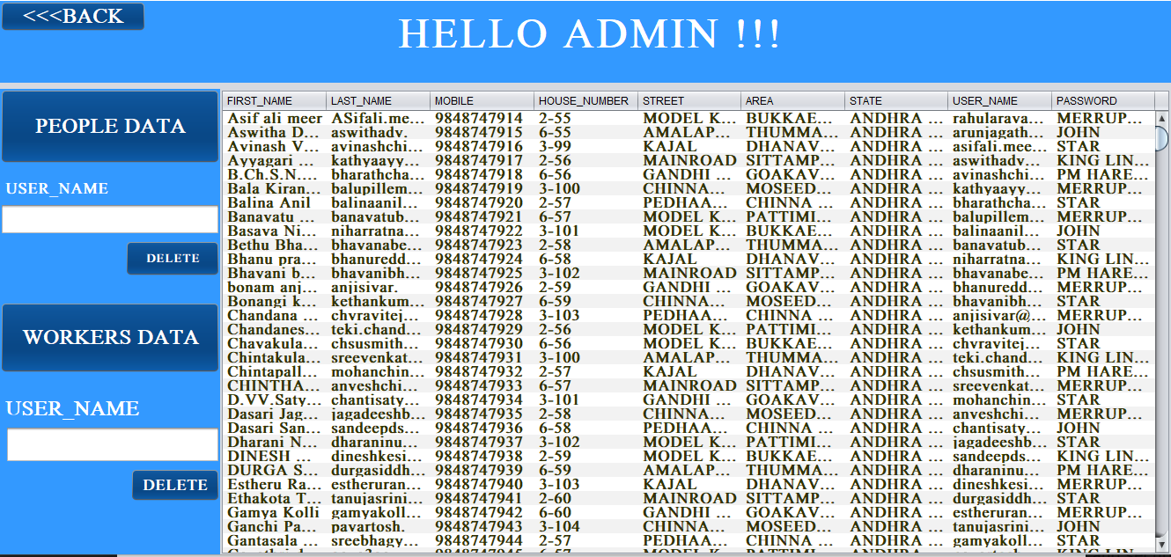**Fig.5.3 workers_data and People_data**

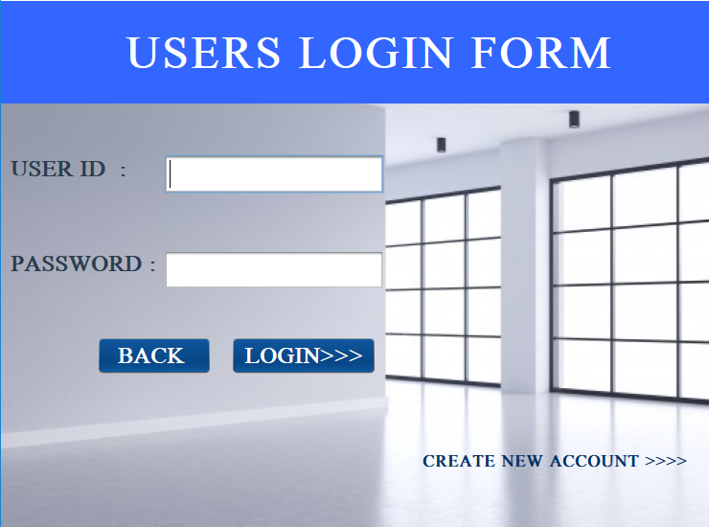**Fig.5.4 User_loginpage**

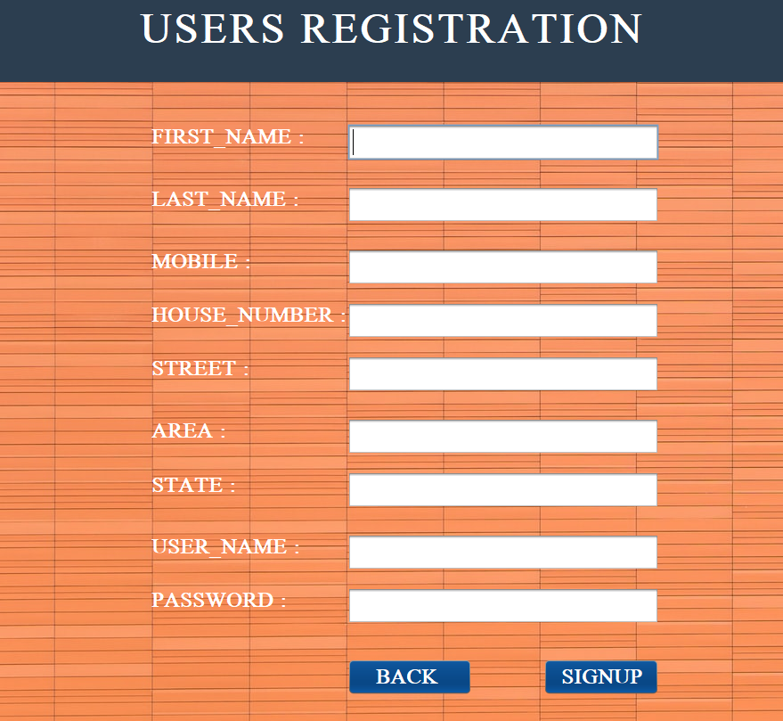

**Fig.5.5 Users_registration_page**

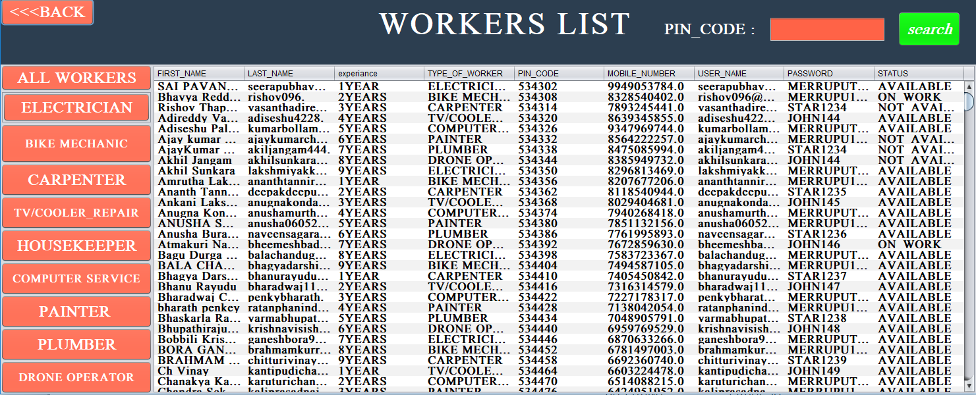

**Fig.5.6 Workers_data**

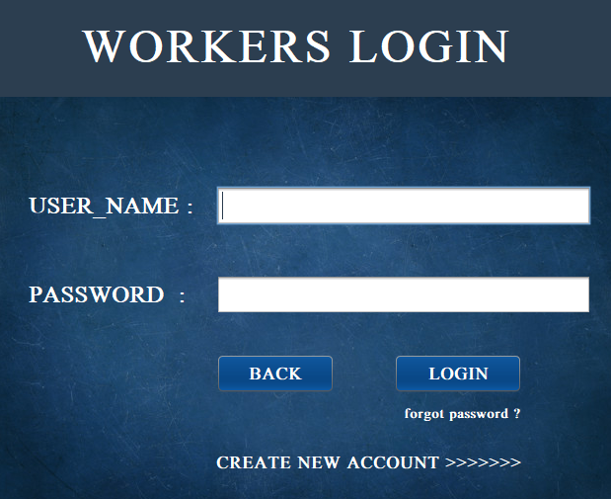

**Fig.5.7 Workers_login_page**

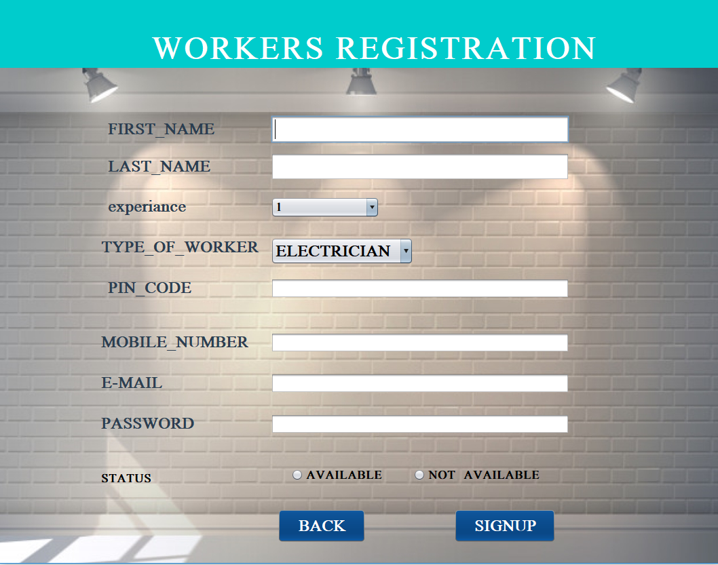

**Fig.5.8 Workers_registration_form**

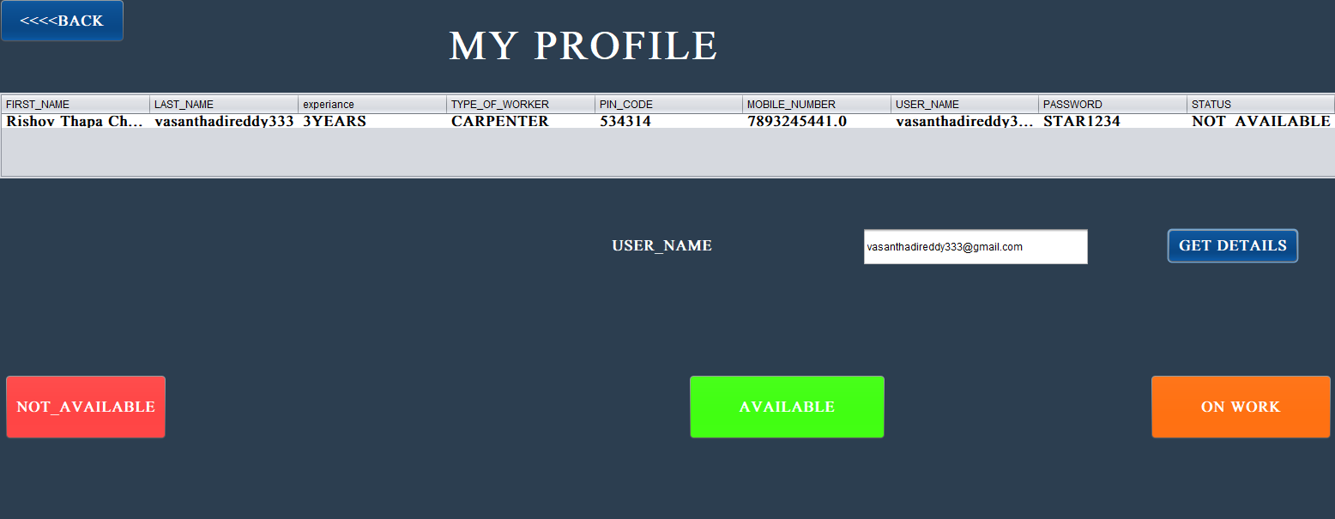

**Fig.5.9 Workers_Profile**

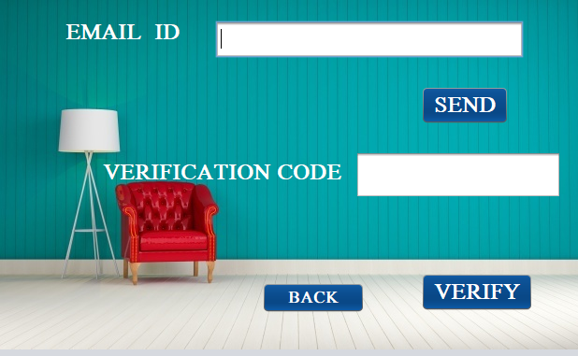

**Fig.5.10 Mail_Verification**

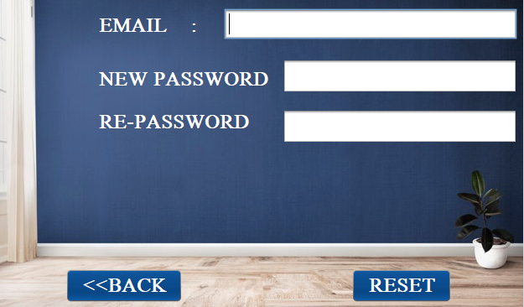

**Fig.5.11 Password_reseting**

**5.CODE**

# Workers_list_people_list1.java

import javax.swing.*;

import javax.swing.table.DefaultTableModel;

import java.awt.*;

import java.sql.*;

import java.awt.event.*;

import net.proteanit.sql.DbUtils;

public class Workers_list_people_list1 extends javax.swing.JFrame {

/**

* Creates new form workers_list1

*/

public Workers_list_people_list1() {

initComponents()

}

@SuppressWarnings("unchecked")

// <editor-fold defaultstate="collapsed" desc="Generated Code">

private void initComponents() {

jPanel1 = new javax.swing.JPanel();

jButton1 = new javax.swing.JButton();

jLabel1 = new javax.swing.JLabel();

jPanel2 = new javax.swing.JPanel();

jButton2 = new javax.swing.JButton();

jButton3 = new javax.swing.JButton();

jButton4 = new javax.swing.JButton();

p1 = new javax.swing.JTextField();

jLabel2 = new javax.swing.JLabel();

jLabel3 = new javax.swing.JLabel();

jButton5 = new javax.swing.JButton();

p2 = new javax.swing.JTextField();

jScrollPane1 = new javax.swing.JScrollPane();

t1 = new javax.swing.JTable();

jLabel4 = new javax.swing.JLabel();

setDefaultCloseOperation(javax.swing.WindowConstants.EXIT_ON_CLOSE);

getContentPane().setLayout(new org.netbeans.lib.awtextra.AbsoluteLayout());

jPanel1.setBackground(new java.awt.Color(51, 153, 255));

jButton1.setBackground(new java.awt.Color(0, 51, 102));

jButton1.setFont(new java.awt.Font("Mongolian Baiti", 1, 24)); // NOI18N

jButton1.setForeground(new java.awt.Color(255, 255, 255));

jButton1.setText("<<<BACK");

jButton1.addActionListener(new java.awt.event.ActionListener() {

public void actionPerformed(java.awt.event.ActionEvent evt) {

jButton1ActionPerformed(evt);

}

});

jLabel1.setBackground(new java.awt.Color(255, 153, 0));

jLabel1.setFont(new java.awt.Font("Mongolian Baiti", 1, 48)); // NOI18N

jLabel1.setForeground(new java.awt.Color(255, 255, 255));

jLabel1.setText("HELLO ADMIN !!!");

javax.swing.GroupLayout jPanel1Layout = new javax.swing.GroupLayout(jPanel1);

jPanel1.setLayout(jPanel1Layout);

jPanel1Layout.setHorizontalGroup(

jPanel1Layout.createParallelGroup(javax.swing.GroupLayout.Alignment.LEADING)

.addGroup(jPanel1Layout.createSequentialGroup()

.addComponent(jButton1, javax.swing.GroupLayout.PREFERRED_SIZE, 166, javax.swing.GroupLayout.PREFERRED_SIZE)

.addGap(286, 286, 286)

.addComponent(jLabel1, javax.swing.GroupLayout.PREFERRED_SIZE, 471, javax.swing.GroupLayout.PREFERRED_SIZE)

.addGap(0, 407, Short.MAX_VALUE))

);

jPanel1Layout.setVerticalGroup(

jPanel1Layout.createParallelGroup(javax.swing.GroupLayout.Alignment.LEADING)

.addGroup(jPanel1Layout.createSequentialGroup()

.addComponent(jButton1, javax.swing.GroupLayout.PREFERRED_SIZE, 35, javax.swing.GroupLayout.PREFERRED_SIZE)

.addGap(0, 0, Short.MAX_VALUE))

.addGroup(javax.swing.GroupLayout.Alignment.TRAILING, jPanel1Layout.createSequentialGroup()

.addContainerGap()

.addComponent(jLabel1, javax.swing.GroupLayout.DEFAULT_SIZE, 65, Short.MAX_VALUE)

.addGap(22, 22, 22))

);

getContentPane().add(jPanel1, new org.netbeans.lib.awtextra.AbsoluteConstraints(0, 0, 1330, -1));

jPanel2.setBackground(new java.awt.Color(51, 153, 255));

jButton2.setBackground(new java.awt.Color(0, 51, 102));

jButton2.setFont(new java.awt.Font("Mongolian Baiti", 1, 24)); // NOI18N

jButton2.setForeground(new java.awt.Color(255, 255, 255));

jButton2.setText("PEOPLE DATA");

jButton2.addActionListener(new java.awt.event.ActionListener() {

public void actionPerformed(java.awt.event.ActionEvent evt) {

jButton2ActionPerformed(evt);

}

});

jButton3.setBackground(new java.awt.Color(0, 51, 102));

jButton3.setFont(new java.awt.Font("Mongolian Baiti", 1, 24)); // NOI18N

jButton3.setForeground(new java.awt.Color(255, 255, 255));

jButton3.setText("WORKERS DATA");

jButton3.addActionListener(new java.awt.event.ActionListener() {

public void actionPerformed(java.awt.event.ActionEvent evt) {

jButton3ActionPerformed(evt);

}

});

jButton4.setBackground(new java.awt.Color(0, 51, 102));

jButton4.setFont(new java.awt.Font("Mongolian Baiti", 1, 14)); // NOI18N

jButton4.setForeground(new java.awt.Color(255, 255, 255));

jButton4.setText("DELETE");

jButton4.addActionListener(new java.awt.event.ActionListener() {

public void actionPerformed(java.awt.event.ActionEvent evt) {

jButton4ActionPerformed(evt);

}

});

p1.setFont(new java.awt.Font("Mongolian Baiti", 1, 24)); // NOI18N

jLabel2.setFont(new java.awt.Font("Mongolian Baiti", 1, 18)); // NOI18N

jLabel2.setForeground(new java.awt.Color(255, 255, 255));

jLabel2.setText("USER_NAME");

jLabel3.setBackground(new java.awt.Color(204, 255, 0));

jLabel3.setFont(new java.awt.Font("Mongolian Baiti", 1, 24)); // NOI18N

jLabel3.setForeground(new java.awt.Color(255, 255, 255));

jLabel3.setText("USER_NAME");

jButton5.setBackground(new java.awt.Color(0, 51, 102));

jButton5.setFont(new java.awt.Font("Mongolian Baiti", 1, 18)); // NOI18N

jButton5.setForeground(new java.awt.Color(255, 255, 255));

jButton5.setText("DELETE");

jButton5.addActionListener(new java.awt.event.ActionListener() {

public void actionPerformed(java.awt.event.ActionEvent evt) {

jButton5ActionPerformed(evt);

}

});

p2.setFont(new java.awt.Font("Mongolian Baiti", 1, 24)); // NOI18N

javax.swing.GroupLayout jPanel2Layout = new javax.swing.GroupLayout(jPanel2);

jPanel2.setLayout(jPanel2Layout);

jPanel2Layout.setHorizontalGroup(

jPanel2Layout.createParallelGroup(javax.swing.GroupLayout.Alignment.LEADING)

.addComponent(jButton2, javax.swing.GroupLayout.Alignment.TRAILING, javax.swing.GroupLayout.DEFAULT_SIZE, javax.swing.GroupLayout.DEFAULT_SIZE, Short.MAX_VALUE)

.addComponent(p1)

.addComponent(jButton3, javax.swing.GroupLayout.DEFAULT_SIZE, 250, Short.MAX_VALUE)

.addGroup(javax.swing.GroupLayout.Alignment.TRAILING, jPanel2Layout.createSequentialGroup()

.addGap(0, 0, Short.MAX_VALUE)

.addGroup(jPanel2Layout.createParallelGroup(javax.swing.GroupLayout.Alignment.LEADING)

.addComponent(jButton4, javax.swing.GroupLayout.Alignment.TRAILING, javax.swing.GroupLayout.PREFERRED_SIZE, 108, javax.swing.GroupLayout.PREFERRED_SIZE)

.addComponent(jButton5, javax.swing.GroupLayout.Alignment.TRAILING)))

.addGroup(jPanel2Layout.createSequentialGroup()

.addContainerGap()

.addGroup(jPanel2Layout.createParallelGroup(javax.swing.GroupLayout.Alignment.LEADING)

.addGroup(jPanel2Layout.createSequentialGroup()

.addGroup(jPanel2Layout.createParallelGroup(javax.swing.GroupLayout.Alignment.LEADING)

.addComponent(jLabel2)

.addComponent(jLabel3))

.addContainerGap(86, Short.MAX_VALUE))

.addComponent(p2)))

);

jPanel2Layout.setVerticalGroup(

jPanel2Layout.createParallelGroup(javax.swing.GroupLayout.Alignment.LEADING)

.addGroup(jPanel2Layout.createSequentialGroup()

.addComponent(jButton2, javax.swing.GroupLayout.PREFERRED_SIZE, 85, javax.swing.GroupLayout.PREFERRED_SIZE)

.addGap(18, 18, 18)

.addComponent(jLabel2, javax.swing.GroupLayout.PREFERRED_SIZE, 21, javax.swing.GroupLayout.PREFERRED_SIZE)

.addPreferredGap(javax.swing.LayoutStyle.ComponentPlacement.RELATED)

.addComponent(p1, javax.swing.GroupLayout.PREFERRED_SIZE, 36, javax.swing.GroupLayout.PREFERRED_SIZE)

.addPreferredGap(javax.swing.LayoutStyle.ComponentPlacement.RELATED)

.addComponent(jButton4, javax.swing.GroupLayout.PREFERRED_SIZE, 41, javax.swing.GroupLayout.PREFERRED_SIZE)

.addGap(29, 29, 29)

.addComponent(jButton3, javax.swing.GroupLayout.PREFERRED_SIZE, 81, javax.swing.GroupLayout.PREFERRED_SIZE)

.addGap(26, 26, 26)

.addComponent(jLabel3, javax.swing.GroupLayout.PREFERRED_SIZE, 28, javax.swing.GroupLayout.PREFERRED_SIZE)

.addPreferredGap(javax.swing.LayoutStyle.ComponentPlacement.RELATED)

.addComponent(p2, javax.swing.GroupLayout.DEFAULT_SIZE, 38, Short.MAX_VALUE)

.addPreferredGap(javax.swing.LayoutStyle.ComponentPlacement.RELATED)

.addComponent(jButton5, javax.swing.GroupLayout.PREFERRED_SIZE, 38, javax.swing.GroupLayout.PREFERRED_SIZE)

.addGap(61, 61, 61))

);

getContentPane().add(jPanel2, new org.netbeans.lib.awtextra.AbsoluteConstraints(0, 100, 250, 530));

t1.setFont(new java.awt.Font("Mongolian Baiti", 1, 18)); // NOI18N

t1.setForeground(new java.awt.Color(51, 51, 0));

t1.setModel(new javax.swing.table.DefaultTableModel(

new Object [][] {

{null, null, null, null},

{null, null, null, null},

{null, null, null, null},

{null, null, null, null}

},

new String [] {

"Title 1", "Title 2", "Title 3", "Title 4"

}

));

jScrollPane1.setViewportView(t1);

getContentPane().add(jScrollPane1, new org.netbeans.lib.awtextra.AbsoluteConstraints(250, 100, 1080, 530));

jLabel4.setText("jLabel4");

getContentPane().add(jLabel4, new org.netbeans.lib.awtextra.AbsoluteConstraints(590, 320, -1, -1));

pack();

}// </editor-fold>

private void jButton2ActionPerformed(java.awt.event.ActionEvent evt) {

try

{

Connection con;

Class.forName("com.mysql.jdbc.Driver");

con=DriverManager.getConnection("jdbc:mysql://localhost:3306/local_workers","root","");

PreparedStatement ps=con.prepareStatement("select * from users_data");

ResultSet rs =ps.executeQuery();

t1.setModel(DbUtils.resultSetToTableModel(rs));

}

catch(Exception e)

{

System.out.println("error "+e);

}

// TODO add your handling code here:

}

private void jButton3ActionPerformed(java.awt.event.ActionEvent evt) {

try

{

Connection con;

Class.forName("com.mysql.jdbc.Driver");

con=DriverManager.getConnection("jdbc:mysql://localhost:3306/local_workers","root","");

PreparedStatement ps=con.prepareStatement("select * from workers_data");

ResultSet rs =ps.executeQuery();

t1.setModel(DbUtils.resultSetToTableModel(rs));

}

catch(Exception e)

{

System.out.println("error "+e);

}

// TODO add your handling code here:

}

private void jButton1ActionPerformed(java.awt.event.ActionEvent evt) {

FIRSTPAGE p=new FIRSTPAGE();

p.setVisible(true);

dispose();

// TODO add your handling code here:

}

private void jButton4ActionPerformed(java.awt.event.ActionEvent evt) {

String USER_NAME=p1.getText();

try

{

// String USER_NAME=t2.getText();

Connection con;

Class.forName("com.mysql.jdbc.Driver");

con=DriverManager.getConnection("jdbc:mysql://localhost:3306/local_workers","root","");

PreparedStatement ps=con.prepareStatement("DELETE FROM `users_data` WHERE USER_NAME='"+USER_NAME+"' ");

// JOptionPane.showMessageDialog(this, " you are AVAILABLE NOW ");

//ps.setString(1,USER_NAME);

ps.executeUpdate();

con.close();

}

catch(Exception e)

{

System.out.println("error"+e);

}

// TODO add your handling code here:

}

private void jButton5ActionPerformed(java.awt.event.ActionEvent evt) {

String USER_NAME=p2.getText();

try

{

// String USER_NAME=t2.getText();

Connection con;

Class.forName("com.mysql.jdbc.Driver");

con=DriverManager.getConnection("jdbc:mysql://localhost:3306/local_workers","root","");

PreparedStatement ps=con.prepareStatement("DELETE FROM `workers_data` WHERE USER_NAME='"+USER_NAME+"' ");

// JOptionPane.showMessageDialog(this, " you are AVAILABLE NOW ");

//ps.setString(1,USER_NAME);

ps.executeUpdate();

con.close();

}

catch(Exception e)

{

System.out.println("error"+e);

}

// TODO add your handling code here:

}

/**

* auother Star sai pavan

*/

public static void main(String args[]) {

/* Set the Nimbus look and feel */

//<editor-fold defaultstate="collapsed" desc=" Look and feel setting code (optional) ">

/* If Nimbus (introduced in Java SE 6) is not available, stay with the default look and feel.

* For details see http://download.oracle.com/javase/tutorial/uiswing/lookandfeel/plaf.html

*/

try {

for (javax.swing.UIManager.LookAndFeelInfo info : javax.swing.UIManager.getInstalledLookAndFeels()) {

if ("Nimbus".equals(info.getName())) {

javax.swing.UIManager.setLookAndFeel(info.getClassName());

break;

}

}

} catch (ClassNotFoundException ex) {

java.util.logging.Logger.getLogger(Workers_list_people_list1.class.getName()).log(java.util.logging.Level.SEVERE, null, ex);

} catch (InstantiationException ex) {

java.util.logging.Logger.getLogger(Workers_list_people_list1.class.getName()).log(java.util.logging.Level.SEVERE, null, ex);

} catch (IllegalAccessException ex) {

java.util.logging.Logger.getLogger(Workers_list_people_list1.class.getName()).log(java.util.logging.Level.SEVERE, null, ex);

} catch (javax.swing.UnsupportedLookAndFeelException ex) {

java.util.logging.Logger.getLogger(Workers_list_people_list1.class.getName()).log(java.util.logging.Level.SEVERE, null, ex);

}

//</editor-fold>

//</editor-fold>

/* Create and display the form */

java.awt.EventQueue.invokeLater(new Runnable() {

public void run() {

new Workers_list_people_list1().setVisible(true);

}

});

}

// Variables declaration - do not modify

private javax.swing.JButton jButton1;

private javax.swing.JButton jButton2;

private javax.swing.JButton jButton3;

private javax.swing.JButton jButton4;

private javax.swing.JButton jButton5;

private javax.swing.JLabel jLabel1;

private javax.swing.JLabel jLabel2;

private javax.swing.JLabel jLabel3;

private javax.swing.JLabel jLabel4;

private javax.swing.JPanel jPanel1;

private javax.swing.JPanel jPanel2;

private javax.swing.JScrollPane jScrollPane1;

private javax.swing.JTextField p1;

private javax.swing.JTextField p2;

private javax.swing.JTable t1;

// End of variables declaration

}